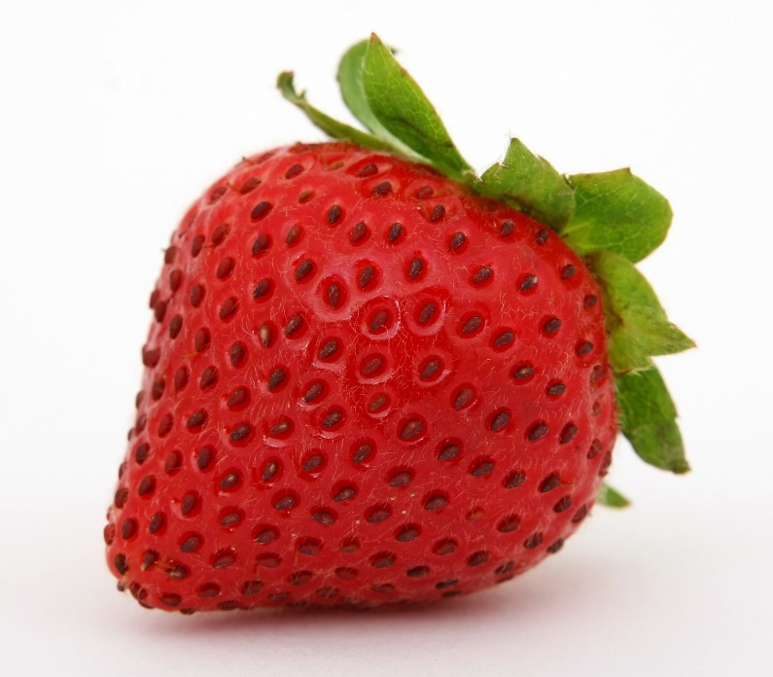

**Strawberry Festival**

Friday, June 21

4 – 7 pm

Circleville Global Methodist Church

Fellowship Hall

11600 Parkway Drive

North Huntingdon, PA 15642